 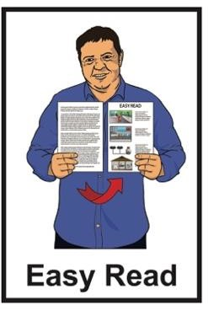

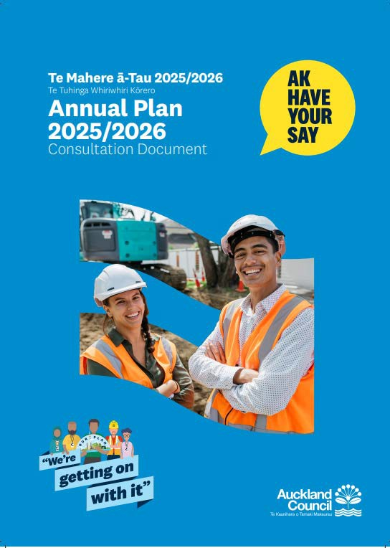Have your say about the Auckland annual plan

# Published: February 2025

**What you will find in here**

### Page number:

What this Easy Read is about 2

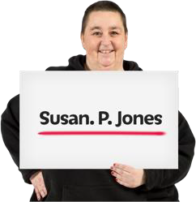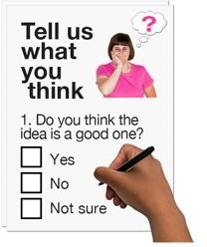About you 5

Your feedback 11

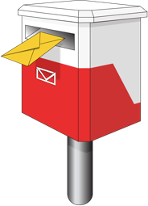Where to send this form 26

**What this Easy Read is about**

This Easy Read form is from Auckland **Council**.



**Council** means the people who make choices about how to run a

town / city.

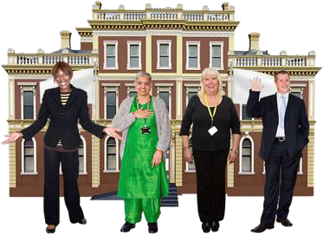

When you see **we** / **us** / **our** in this Easy Read it means **Auckland**

**Council**.

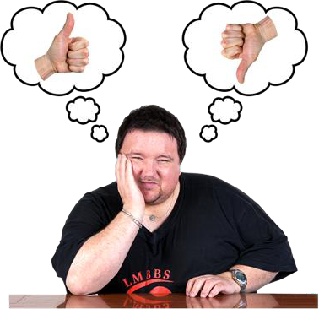This Easy Read form is for you to tell us what you think about our

### annual plan.

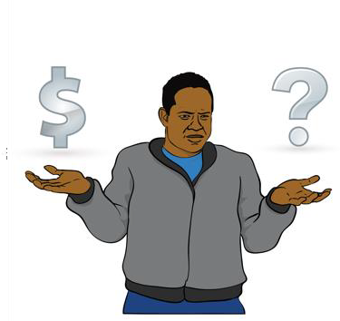

The **annual plan** says how we will spend our money in the coming year.

The annual plan is sometimes called the annual budget.

You can find out more about the annual plan in the Easy Read **Information about the Auckland Council annual plan** at:

### akhaveyoursay.nz/ourplan

We will call **Information about the Auckland Council annual plan** the

**information document**.

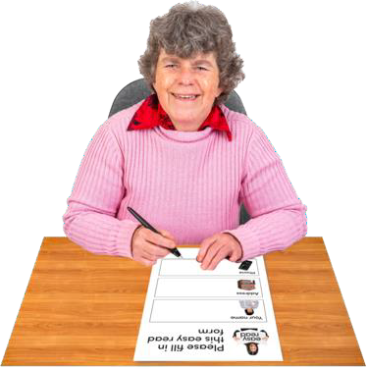You can write your answers on this form.

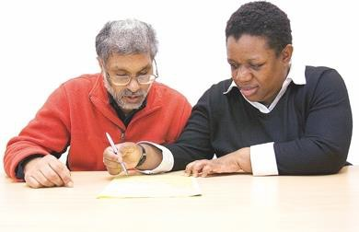You can ask someone to support you to write your answers.

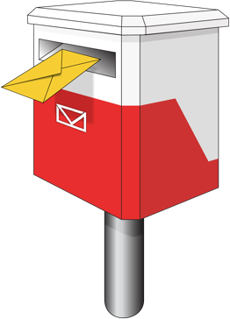There is information about where to send this form on pages **26 to 27** of this form.

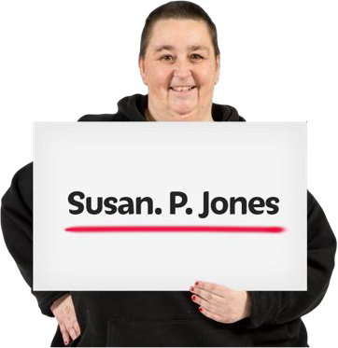Other people will be able to see:

* your name
* your **feedback**.



**Feedback** means the things you tell

us about the annual plan.

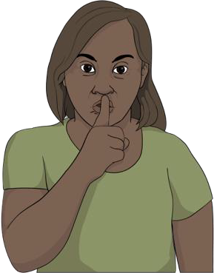We will not share any other information about you.

**About you**

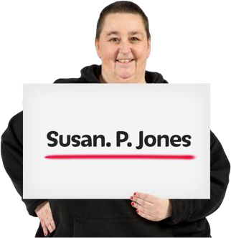Write your full name in this box.

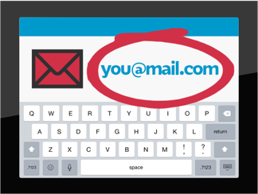Use the box below to write your:

* email address

### or

* postal address

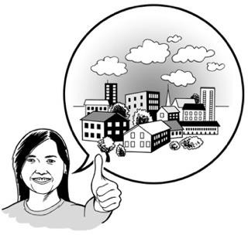Use the box below to write your **local board** / suburb where you live.

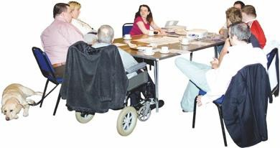

**Local boards** make choices about how to run things in their part of a

town / city.

You can use this **website** to find your local board:

[**https://tinyurl.com/2dnrd8af**](https://tinyurl.com/2dnrd8af)

Please put a tick in the box that is right for you:

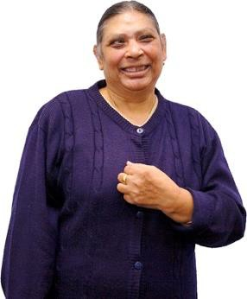I am answering these questions:

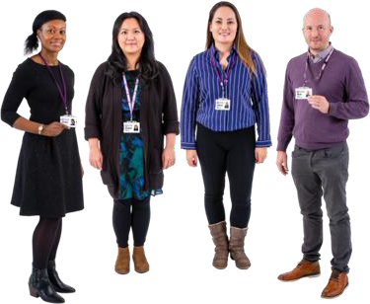 just for myself

 as part of an organisation.

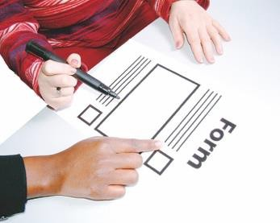If you said you were answering as part of an organisation write its name in this box.

You can choose if you want to tell us more about yourself.

Telling us more about yourself will give us information about the kinds of people who are giving us feedback.

Write your **gender** in the box.

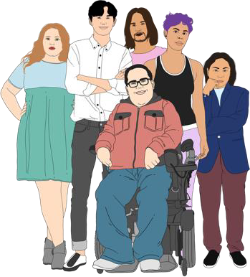

**Gender** is if you are:

•

a man

•

a woman

•

another gender like nonbinary.

Write your age in the box.

Put a tick in all the boxes that are right for you.

My ethnicity is:

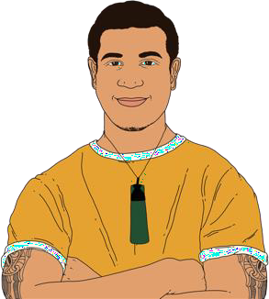 Pākehā / NZ European  Māori

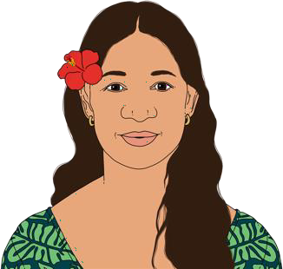 Samoan

Cook Islands Māori

Here are some more boxes you can tick about your ethnicity.

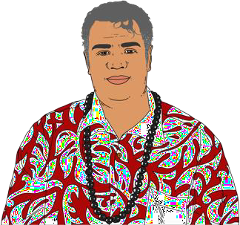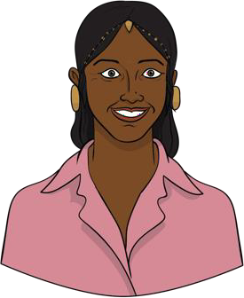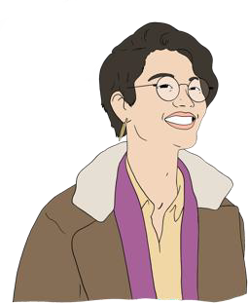 Tongan  Indian  Korean

 Southeast Asian

 something else – please tell us in the box below.

**Your feedback**

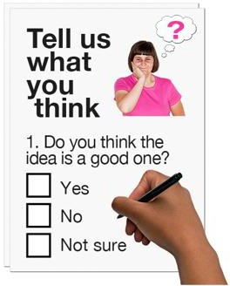You can answer as many questions as you want to.

You do not have to answer all the questions.

## Question 1 – Our overall plan

The question on the next page is about what you think about the annual plan as a whole.

Put a tick in the box beside the answer that is closest to what you think.

 I agree with **everything** in the annual plan.

 I agree with **most** things in the annual plan.

 I do **not** agree with most things in the annual plan.

 I do **not** agree with anything in the annual plan.

I do not know.

Write in the box to tell us why you chose your answer about what you think of the annual plan as a whole.

## Question 2 – Bed Night Visitor Levy

A **bed night visitor levy** is money that is paid to the council when

someone stays somewhere like a:

•

hotel

•

motel.

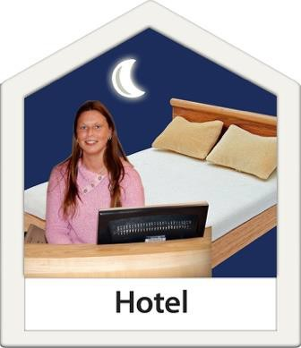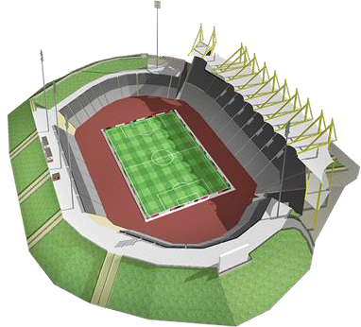We want to charge a bed night visitor levy to pay for some of the cost of putting on events in Tāmaki Makaurau Auckland.

There is more information about the bed night visitor levy on **pages 19 to 20** of the information document.

Put a tick in the box beside the answer that is closest to what you think.

 I think Auckland Council should charge a bed night

visitor levy.

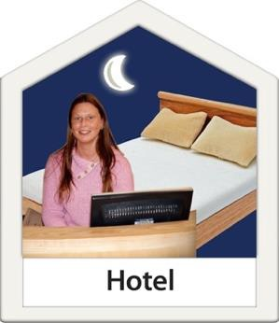 I think Auckland Council should **not** charge a bed night visitor levy.

 I think something different about Auckland Council charging a bed night visitor levy.

I do not know.

Write in the box to tell us why you chose your answer about Auckland Council charging a bed night

visitor levy.

## Question 3 – Rates and Fees

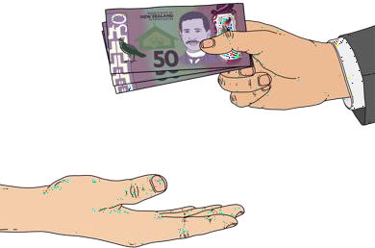The next questions are about money that people in Tāmaki Makaurau Auckland pay to the council like:

### rates

* 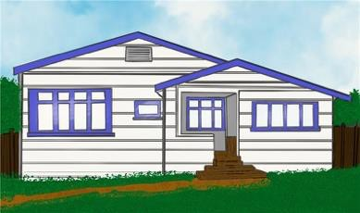**fees**.

**Rates** means money that people who own houses in Tāmaki Makaurau Auckland pay to the council.

People who pay rates are called ratepayers

The council uses rates to pay for things like libraries.



Here **fees** means money people pay

to the council for things that are not paid for by rates.

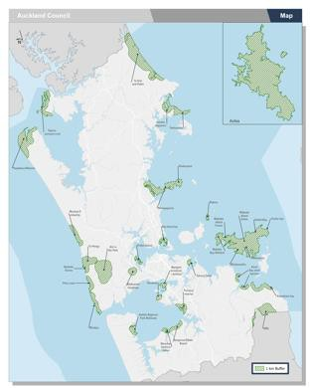We plan to change rubbish collection in:

* Franklin
* Rodney.

Ratepayers in these areas will:

* 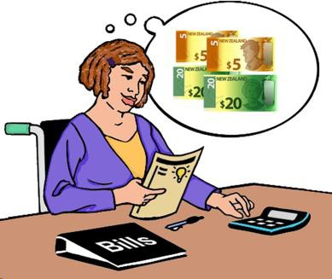pay a rubbish collection fee on their rates bill
* not need to buy rubbish bags anymore.

There is more information about changes to rubbish collection on **pages 17 to 18** of the information document**.**

Put a tick in the box beside the answer that is closest to what you think.

I agree with the changes to rubbish collection.

I do **not** agree with the changes to rubbish collection.

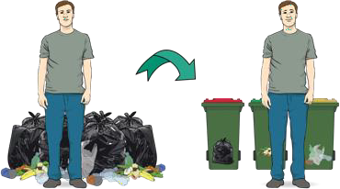I think something different about the changes to rubbish collection..

I do not know.

Write in the box to tell us why you chose your answer about the changes to rubbish collection.

There is more information about rates

on **pages 16 to 17** of the information document**.**

Use the box to tell us anything else you want to say about rates / fees in Tāmaki Makaurau Auckland.

## Question 4 – Local board plans

There is more information about local

boards on **pages 14 to 15** of the information document**.**

Write the name of the local board you are giving feedback about in the box below.

Put a tick in the box beside the answer that is closest to what you think.

I agree with everything this local board does.

I agree with most things this local board does.

I do **not** agree with most things this local board does.

I do **not** agree with anything this local board does.

I do not know.

Write in the box to tell us why you chose your answer about the local board.

## Question 5 – other feedback

Use the box to write anything else you want to tell us about the annual plan.

**Where to send this form**

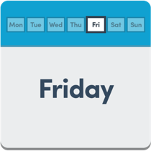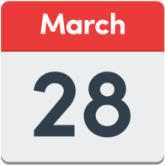You have to send your form to us before **Friday 28 March**.

You can **post** this form to:

**Attention: Annual Plan, Auckland Council Freepost Authority 182382**

**Private Bag 92300**

**Auckland 1140**

You do **not** need a stamp to post this form.

You can also take this form to a:

* service centre
* library.

There is a list of our service centres on our **website** at:

[**https://tinyurl.com/mr3my6s3**](https://tinyurl.com/mr3my6s3)

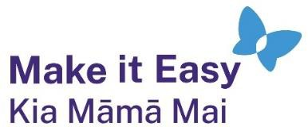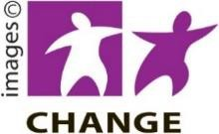

This information has been written by Auckland Council Te Kaunihera o Tāmaki Makarau.

It has been translated into Easy Read by the Make it Easy Kia Māmā Mai service of People First New Zealand Ngā Tāngata Tuatahi.

The ideas in this document are not the ideas of People First New Zealand Ngā Tāngata Tuatahi.

All images used in this Easy Read document are subject to copyright rules and cannot be used without permission.

Make it Easy uses images from:

* Photosymbols
* Change Images
* Huriana Kopeke-Te Aho
* SGC Image Works
* T Wood
* Studio Rebeko
* Inga Kramer.