 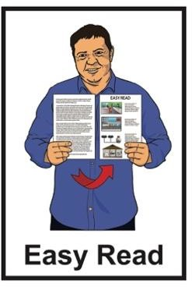

Information about the Auckland Council Annual Plan

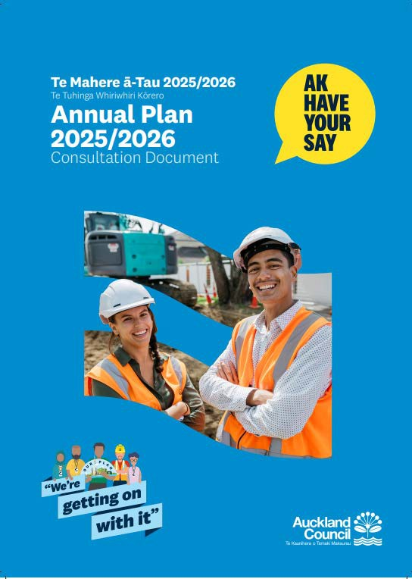

# Published: February 2025

**What you will find in here**

## Page number:

What this Easy Read is about 2

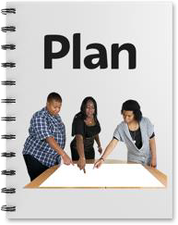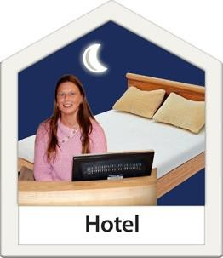What the annual plan says 7

Bed night visitor levy 19

How to have your say 21

**What this ER is about**

This Easy Read is from Auckland **Council**.



**Council** means the people who make choices about how to run a

town / city.

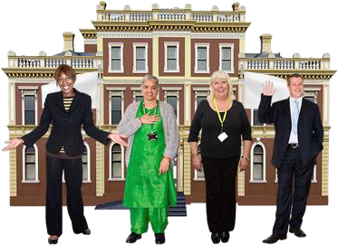

When you see **we** / **us** / **our** in this Easy Read it means **Auckland**

**Council**.

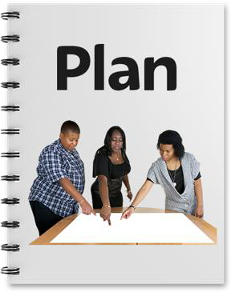This Easy Read is a **summary** of our

**annual plan** for:

* 2025

## to

* 2026.

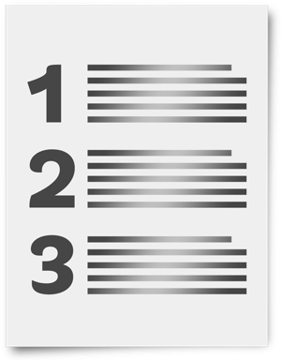

A **summary**:

•

is shorter than the main

document

•

tells you the main points.

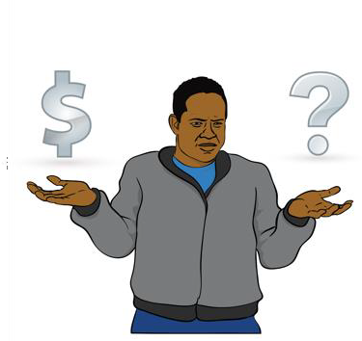

The **annual plan** says how we will spend our money in the coming year.

The annual plan is sometimes called the annual budget.

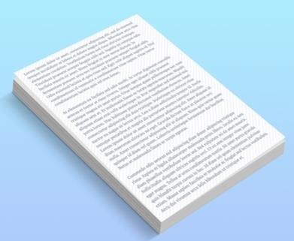At the moment the annual plan is a

## draft.



**Draft** means it:

•

is not the finished document

•

might change.

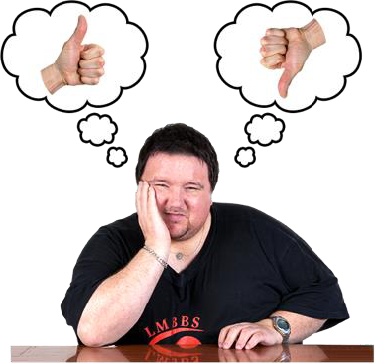We want to know what you think about the annual plan.

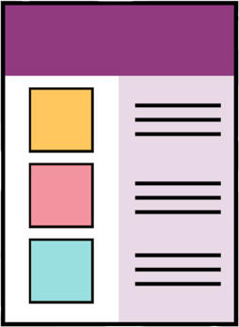

There is information about how to tell us what you think on **pages 21 to 22**

of this Easy Read.

You can read the full annual plan draft on our **website** at:

## [akhaveyoursay.nz/ourplan](https://tinyurl.com/4n986nwc)

This annual plan is for year 2 of our

## long term plan.



The **long term plan** says what we

will do in the 10 years from:

•

2024

**to**

•

2034.

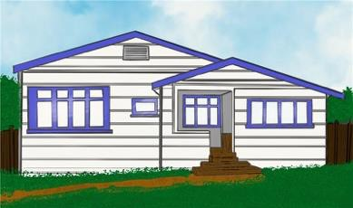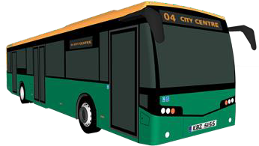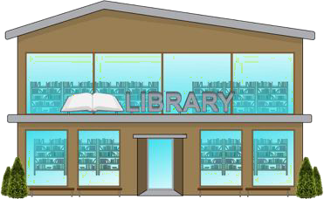The annual plan needs to:

**Rates** means money that people who own houses in Tāmaki Makaurau

Auckland pay to the council.

The council uses rates for things like:

•

libraries

•

buses.

* 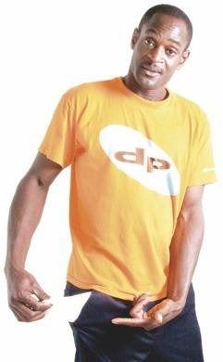make sure the things that are important for Tāmaki Makaurau Auckland can happen
* not cost **ratepayers** too much money.



**Ratepayers** are people who pay

**rates** to the council.

**What the annual plan says**

We want to make Tāmaki Makaurau

Auckland:

* 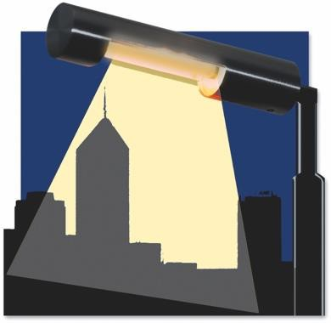beautiful
* safe

## thriving.

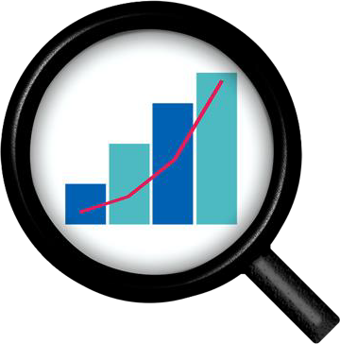

**Thriving** means something is:

•

growing

•

doing well.

We are going to **invest** in 7 important things:

* transport

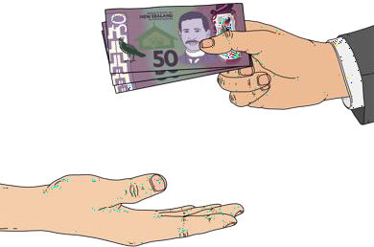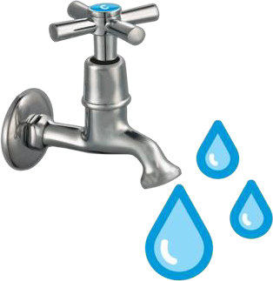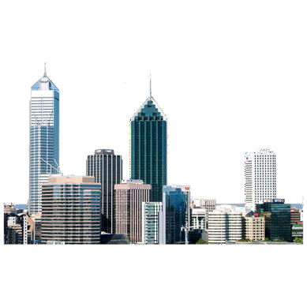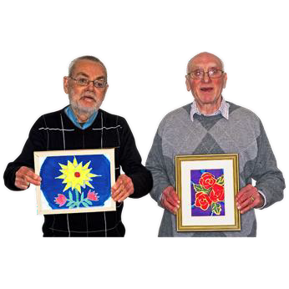

* water
* the natural environment
* our built environment
* the community
* cultural events
* making sure the council runs well.

We will say more about these 7 things in the following pages.

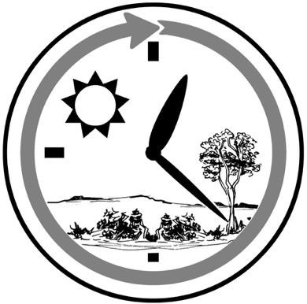

**Invest** means to spend:

•

money

•

time

•

effort.

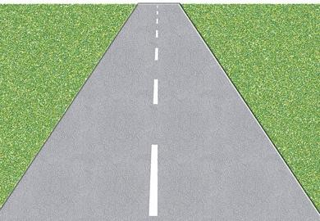We will invest in transport like:

* roads
* public transport like:
  + buses
  + 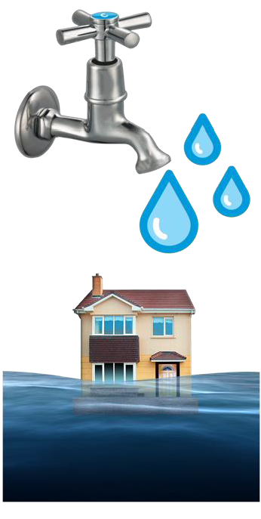ferries.

We will invest in water so everyone in

Tāmaki Makaurau Auckland:

* has clean water
* will be okay if there is a flood.

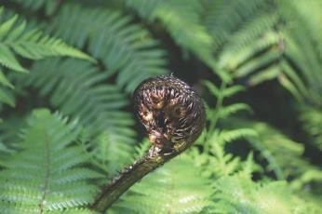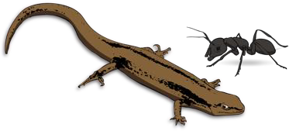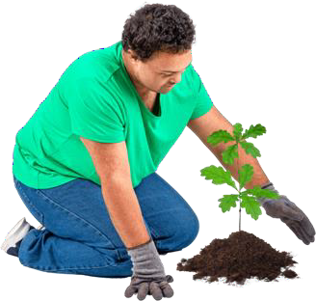We will invest in taking care of our

## A cartoon of a lake surrounded by mountains Description automatically generatednatural environment.

The **natural environment** is

everything around us like:

•

land

•

air

•

lakes / rivers / the sea

•

plants

•

animals.

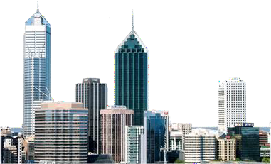We will also invest in taking care of our **built environment**.

**Built environment** means things

like:

•

houses

•

shops

•

ports.

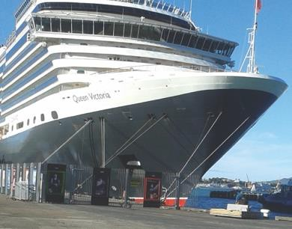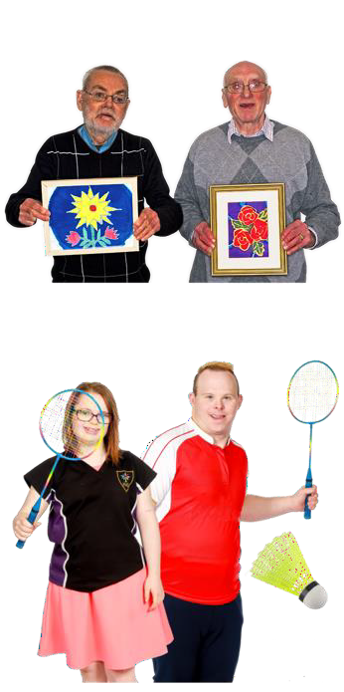We will invest in the community so people can take part in things like:

* art
* sports.

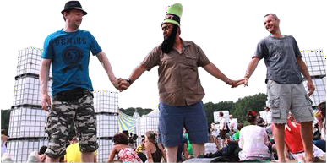We will invest in cultural events like:

* 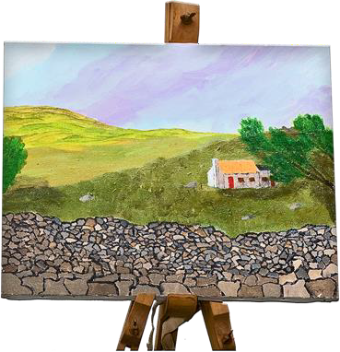concerts
* festivals
* exhibitions.

Cultural events will:

* bring visitors to Tāmaki

Makaurau Auckland

* give people jobs
* make money for businesses.

We will invest in making sure Auckland Council:

* runs smoothly
* manages its money well.

We plan to spend 4 billion dollars on building things like:

* roads
* pipes for things like:
  + water

## sewage.

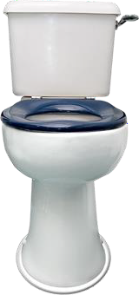

**Sewage** means things that get

flushed down the toilet – like poo.

Auckland has 21 **local boards**.

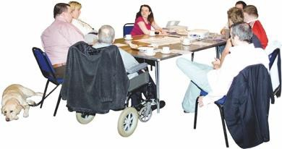

**Local boards** make choices about how to run things in their part of a

town / city.

Some of these local boards do not have enough money to do everything they need.

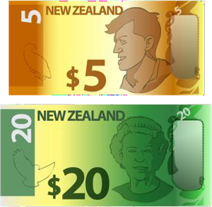

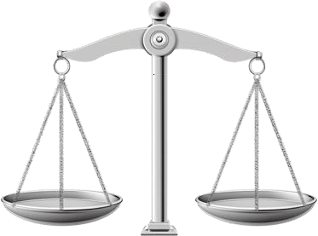We will make changes so local boards can have a fair amount of money.

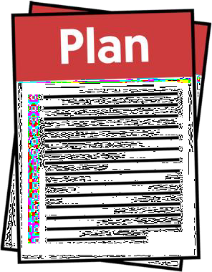Each local board has its own plan.

There is information about local board plans in the **Annual Plan**

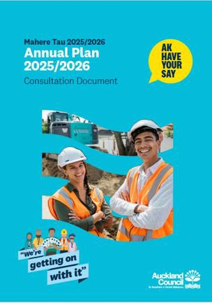

## 2025 / 2026 consultation document

at:

## akhaveyoursay.nz/ourplan

We will put rates up by just under 6

## percent.



**Percent** is a number out of every 1 hundred.

For example if your rates used to be 1 hundred dollars a week they would now be just under 1 hundred and 6

dollars.

For an **average** house in Tāmaki Makaurau Auckland rates will cost around 2 hundred dollars more a year.

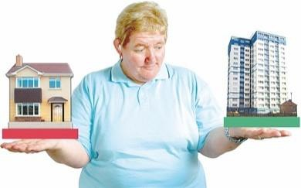

Here **average** means in the middle

between:

•

the cheapest

**and**

•

the most expensive.

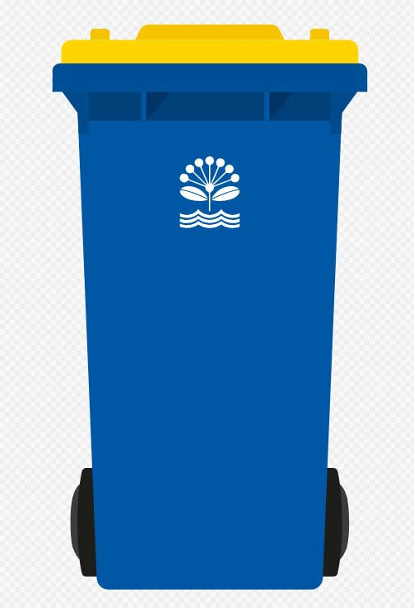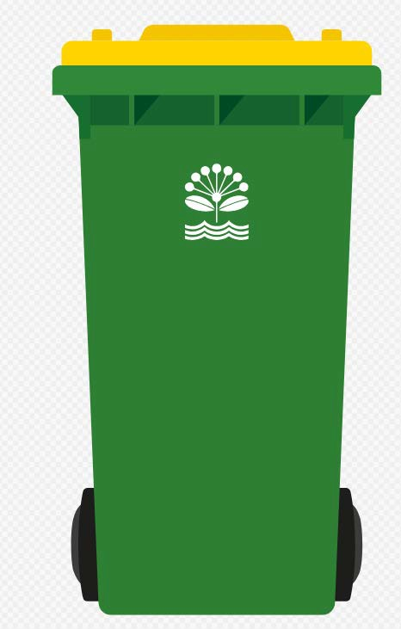At the moment some parts of Tāmaki Makaurau Auckland have 3 bins for rubbish collection:

* 1 bin for rubbish
* 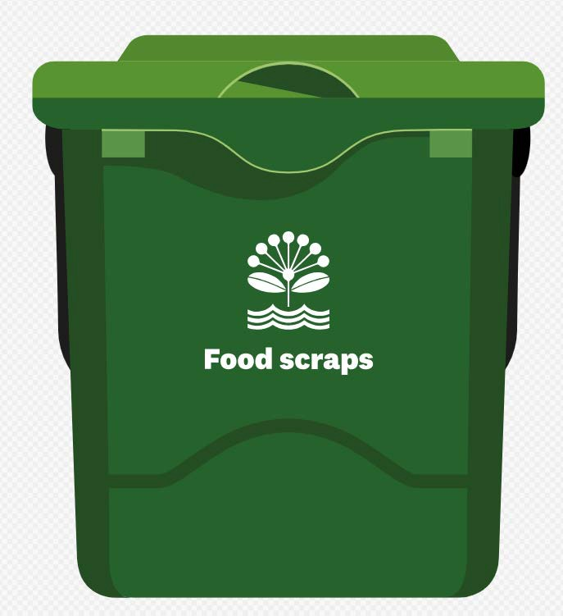1 bin for recycling
* 1 bin for food scraps.

Rate payers in these parts of Tāmaki Makaurau Auckland pay a **fee** on their rates bill for rubbish collection.



Here **fee** means money people pay to the council for things that are not

paid for by rates.

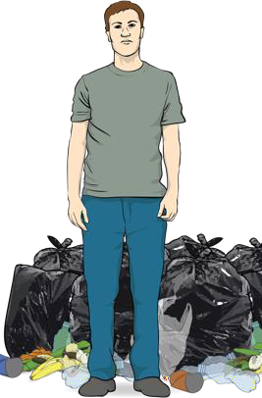Other parts of Tāmaki Makaurau Auckland still use rubbish bags that you have to buy.

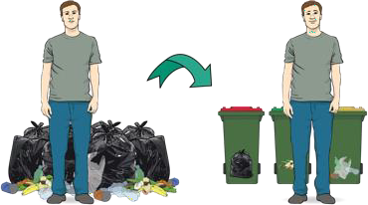We are going to change rubbish collection so everyone in Tāmaki Makaurau has 3 bins.

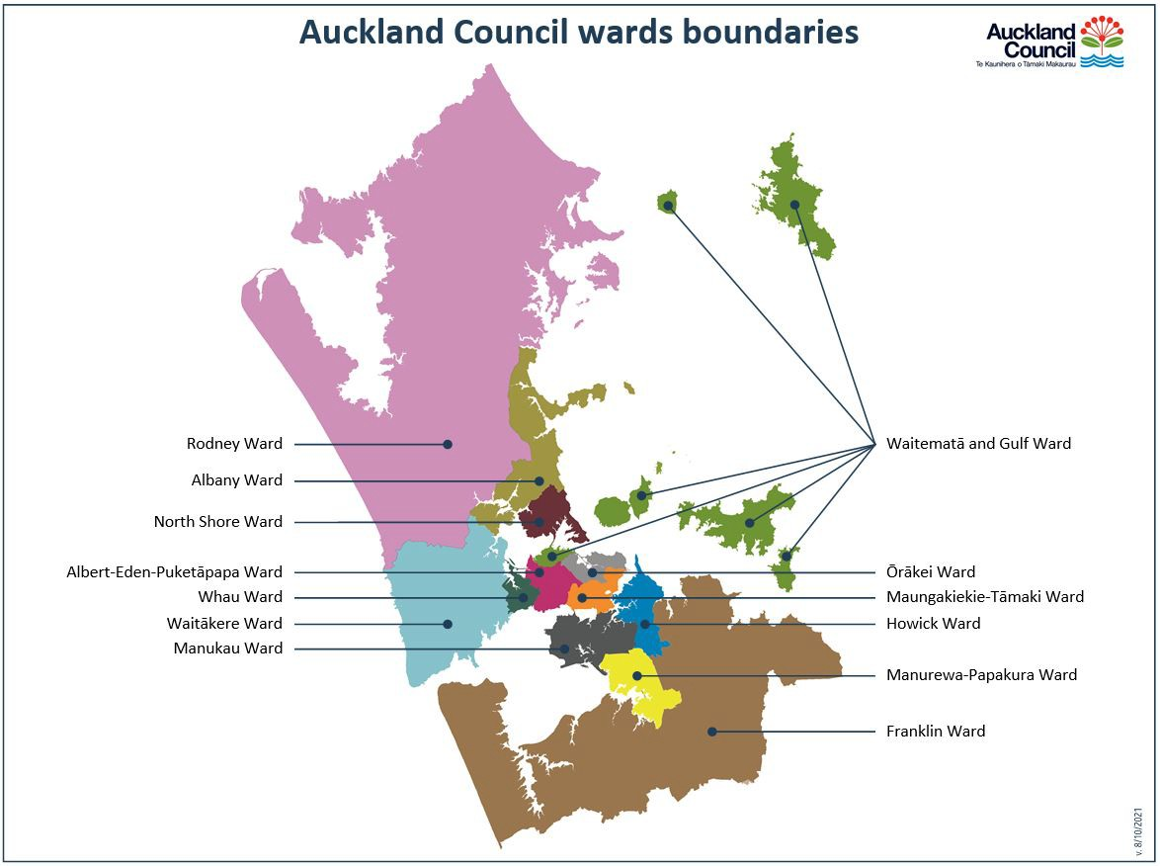The places where rubbish collection will change are:

* Franklin
* Rodney.

Ratepayers in these areas will now pay a fee on their rates bill.

**Bed night visitor levy**

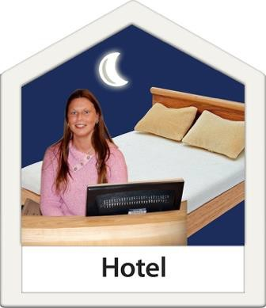

A **bed night visitor levy** is money

that is paid to the council when someone stays somewhere like a:

•

hotel

•

motel.

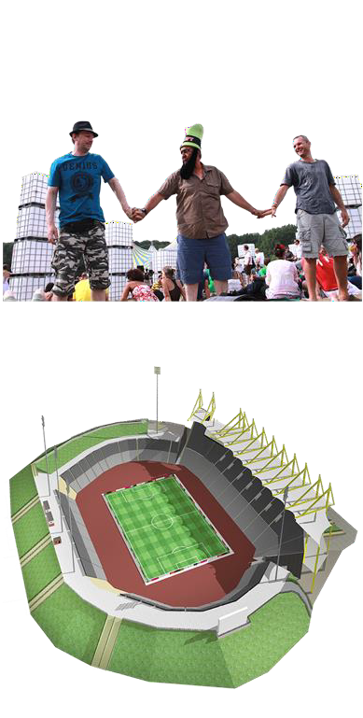It costs a lot of money to put on events like:

* festivals
* sports competitions.

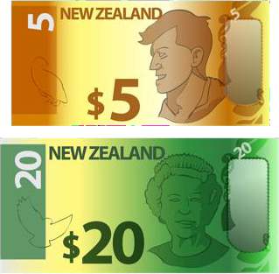We think a bed night visitor levy would be a good way to get money to pay for events.

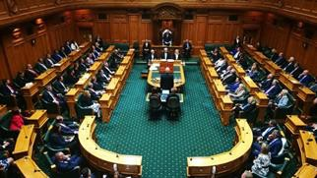We are working with the Government to find a way to charge a bed night visitor levy.

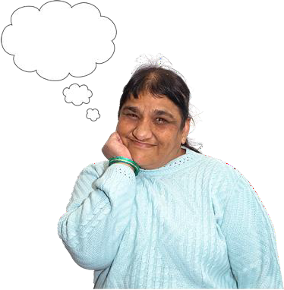The Government has not told us if it will change the law so we can charge a bed night visitor levy.

We want to know what you think about a bed night visitor levy.

**How to have your say**

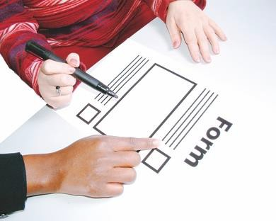You can tell us what you think by filling out the Easy Read form **Auckland annual plan: Have your say** at:

## akhaveyoursay.nz/ourplan

You can tell also us what you think about our annual plan by filling out the form on our **website**:

## [www.akhaveyoursay.nz/ourplan](http://www.akhaveyoursay.nz/ourplan)

You can also tell us what you think by

**visiting** us at a:

* service centre
* library.

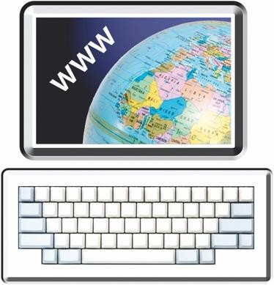There is a list of our service centres on our **website** at:

[**https://tinyurl.com/mr3my6s3**](https://tinyurl.com/mr3my6s3)

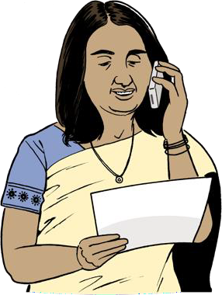You can tell us what you think by

**phone** on:

## 09 301 0101

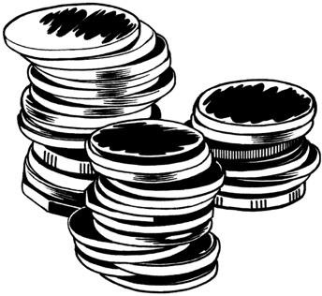It may cost money to phone this number.

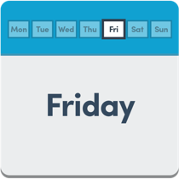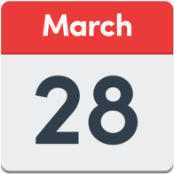You have until **Friday 28 March 2025** to tell us what you think about the annual plan.

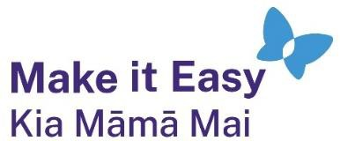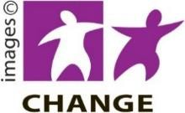

This information has been written by Auckland Council Te Kaunihera o Tāmaki Makarau.

It has been translated into Easy Read by the Make it Easy Kia Māmā Mai service of People First New Zealand Ngā Tāngata Tuatahi.

The ideas in this document are not the ideas of People First New Zealand Ngā Tāngata Tuatahi.

All images used in this Easy Read document are subject to copyright rules and cannot be used without permission.

Make it Easy uses images from:

* Photosymbols
* Change Images
* Huriana Kopeke-Te Aho
* SGC Image Works
* T Wood
* Studio Rebeko
* Inga Kramer.